Supplemental Data I

Wheat 8K cDNA microarray fabrication and technical properties
Microarrays provide the opportunity to simultaneously monitor the expression of thousands of genes at various developmental stages, thus providing an opportunity to analyze the temporal patterns of expression of genes in the same plant material grown in the same environmental conditions. To conduct a comprehensive study of gene expression during
caryopsis development, we generated a cDNA microarray with 10,800 spots representing 7,833 unique genes from wheat. About 30% of the unique probes on the array were identified from cDNA libraries made exclusively from mRNA isolated from developing endosperm and caryopsis tissue. Furthermore, about 75% of the genes on the array have been mapped on the hexaploid wheat genome.
Included on the array are different types of controls that can be used for normalization, and data quality assessment: 18 AFGC microarray controls, which include ten spiking controls, derived from human genes, that do not show cross hybridization with plant RNA, and 23 Lucidea ScoreCard (from Amersham Biosciences) calibration, ratio, utility and negative controls which are artificial genes composed of sequences from yeast intergenic regions. To assess the overall performance of the wheat cDNA array, we analyzed the sensitivity and dynamic range of expression, as well as the within- and between-slide reproducibility.
Sensitivity and dynamic range. Analysis of the spot signals of the 10 Lucidea Score Card calibration controls (Figure A) shows that we can reliably detect a signal from 0.3 pg of the calibration control RNA for every 1 μg of total RNA labeled for hybridization. The data collected had a linear dynamic range of 10⁴.
Assuming that the amplification efficiency of the endogenous wheat RNA is similar to that of the spiked-in calibration controls, the calibration control data will allow us to approximate the number of transcripts of each gene per ug of RNA used for hybridization. Using the estimated 100-500 pg of total RNA in a plant cell (Goldberg et al. 1978; Kerk et al. 2003), and an average of 1,500 nucleotides/molecule of plant mRNA (Alexandrov et al. 2006; Goldberg et al. 1978; Ogihara et al. 2004), the cDNA microarrays are estimated to detect the expression of genes with as low as 36 to 181 RNA transcripts per cell. Using RNA Cot analysis, Goldberg and colleagues, estimated that there are 17 transcripts, 340 transcripts and 4,500 transcripts per cell for low, moderate and highly expressed genes, respectively. Thus, cDNA arrays can almost detect even genes with low level of expression.
Within-slide reproducibility. To assess the reproducibility of the probe signals within slides, we used the data obtained from 10 AFGC mammalian spiking controls spotted on 45 of the 48 subgrids on the array. Each spiking control was spotted 45 times giving 450 data-points per slide per dye. Equal amounts of in vitro transcribed mRNA of each spiking control were added to 10 ug total RNA before indirect labeling with fluorescent dyes. The ratio of the intensity signals for the spiking controls between the Red (Alexa 647) and Green (Alexa 555) channels was expected to be 1. Figure B shows the within-slide reproducibility of the spiking control spot signals obtained from 9 slides. The different colors represent the signal ratio from different slides. The coefficient of correlation between each comparison ranges from 0.94 to 0.99, with an average of 0.97.
Between-slide reproducibility. The between-slide reproducibility was assessed both on technical and biological replicates. To evaluate the reproducibility of technical replicates, the probe signals from 9 slides used to hybridize RNA from one set of biological samples were compared. Figure C shows an example of the distribution of the spots from RNA from the same sample that was independently labeled and hybridized to two different slides. Comparison of the signals obtained from the two independently labeled RNA from the same sample gave a coefficient of correlation of 0.95. Analysis of the between-slide reproducibility of technical replicates on all 9 slides, or 27 comparisons (data not shown) revealed a range of coefficient of correlation of 0.85 to 0.96, with an average of 0.91. Similarly, analysis of the between-slide reproducibility of biological replicates (RNA isolated from 7DPA grains from different plants grown for this experiment) on 27 slides, revealed a coefficient of correlation ranging from 0.72 to 0.97 with an average 0.87. Figure D shows an example of a comparison between two biological replicates that has high between-slide reproducibility.

Figure: Wheat 8K cDNA microarray technical properties
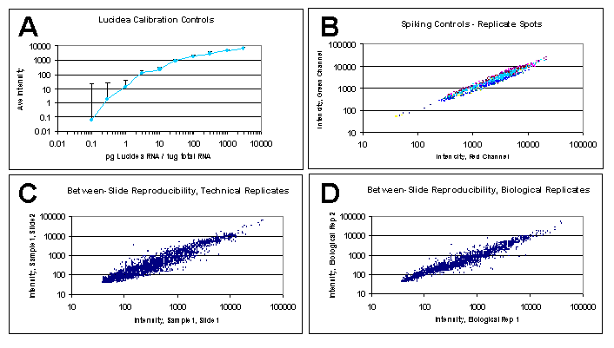

A. Calibration curve from the ten Lucidea Universal ScoreCard controls
DNA of the 10 Lucidea Score Card calibration controls was spotted 4 times on each slide. In vitro transcribed mRNA for each calibration control was spiked in different concentrations: 0.1, 0.3, 1, 3, 10, 30, 100, 300, 1000 and 3000 pg per 1 ug sample total RNA used before labeling. Equal amounts of the calibration control RNA were added to every sample RNA used for the experiment. Probe signals from both the Red (Alexa 647) and Green (Alexa 555) channels from 9 slides were analyzed. The average signal was calculated for each calibration control. The signal intensities for the Red Alexa 647) and Green (Alexa 555) channels have been background subtracted. The average of the corrected raw signal intensities (y-axis) were plotted against the amount of the spiked-in RNA of the calibration control per 1 ug of sample RNA labeled. The half bar on each data point represents the standard deviation from the mean of the corrected signal for each calibration control.

B. Spiking controls and within slide reproducibility
Comparison of the Red (x-axis) and Green (y-axis) channel intensity values for each mammalian spiking control spot within an array. The different colors represent spots from different slides analyzed.

C. Between slide reproducibility –technical replicates
Comparison of the intensity values for the same microarray spot on two different arrays hybridized with the same RNA sample that was independently labeled.

D. Between slide reproducibility –biological replicates
Comparison of the intensity values for the same microarray spot on two different arrays each hybridized with two distinct biological RNA samples for the same time-point.

