UNITED STATES DEPARTMENT OF AGRICULTURE
AGRICULTURAL RESEARCH SERVICE

In cooperation with

STATE AGRICULTURAL EXPERIMENT STATIONS

Report on Hard Red Spring Wheat Varieties Grown in Cooperative Plot and
Nursery Experiments in the Spring Wheat Region in 2025

Nursery Coordinator:
Andrew Read
USDA-ARS
Research Geneticist

Report prepared by: S. Blecha and A. Read

This is a joint progress report of cooperative investigations underway in the State Agricultural Experiment Stations and the Agricultural Research Service of the U.S. Department of Agriculture. It contains preliminary data which have not been sufficiently confirmed to justify general release, and interpretations may be modified after additional experimentation. Confirmed results will be published through established channels. This report is primarily a tool for use by cooperators and their official staffs, and for those persons having direct and special interest in the development of agricultural research programs.

This report includes data furnished by the State Agricultural Experiment Stations as well as by the Agricultural Research Service of the U.S. Department of Agriculture. This report is not intended for publication and should not be referred to in literature citations, nor quoted in publicity or advertising. Accuracy of information within this report is not guaranteed by the U.S. Government.

Use of the data may be granted for certain purposes upon written request to the agency or agencies involved.

USDA is an equal opportunity provider and employer.

Agricultural Research Service
U.S. Department of Agriculture
Midwest Area
St. Paul, Minnesota
February 25, 2026
2025 HARD RED SPRING WHEAT UNIFORM REGIONAL NURSERY REPORT

CONTENTS PAGE

Cooperating Agencies, Stations and Personnel 2

Policy for Protected or Patented Genes 3

Previous HRSWURN Entries Released as New Cultivars 4

2025 Spring Wheat Production Statistics 5

2025 Environmental Notes by Stations 6-7

Description and Summary of 2025 HRSWURN 8

Figure 1. Geographic Locations of 2025 HRSWURN 9

Figure 2. Average trait values by genotypes at all locations for the 2025 HRSWURN 10

Table 1. List of Entries in the 2025 HRSWURN 11

Table 2. Nursery Locations and Comparative Plot Management Data 12

Tables 3-16. Nursery Data by Individual Location 13-26

Table 17. Summary of Trait Means Across Locations 27

Table 18. Yield Rankings by Location 28

Table 19. Seedling and Field Leaf Rust Reactions, St. Paul, MN 29

Table 20. Seedling and Field Stem Rust Reactions, St. Paul, MN 30-31

Table 21. Fusarium Head Blight (Scab) Reactions, St. Paul, MN 32

Table 22. Fusarium Head Blight (Scab) Reactions, Crookston, MN 33

Table 23. Fusarium Head Blight (Scab) Reactions, Fargo, ND 34

Table 24. Fusarium Head Blight (Scab) Reactions, Prosper, ND 35

Table 25. Molecular Marker Data for Agronomic Trait/Disease Resistance Genes 36-37

Table 26. Field Stem and Stripe Rust Reactions in Kenya 38
COOPERATING AGENCIES, STATIONS, AND PERSONNEL FOR THE 2025 HRSWURN

USDA-AGRICULTURAL RESEARCH SERVICE
National Program Leader O. Crasta
Midwest Area Director R. James
Nursery Coordinator, Plant Science Research Unit, St. Paul, MN A. Read
S. Blecha
Quality Investigations, Cereal Crops Research Unit, Fargo, ND L. Dykes
Molecular Marker Analysis, Cereal Crops Research Unit, Fargo, ND J. Fiedler
Disease Evaluations
Cereal Disease Laboratory, St. Paul, MN Y. Jin
P. Olivera
S. Gale
S. Zhong

MINNESOTA AGRICULTURAL EXPERIMENT STATION
St. Paul, University of Minnesota J. Anderson
S. Reynolds
Fergus Falls, Experiment Station J. Wiersma
Crookston, Northwestern Experiment Station M. Leiseth

NORTH DAKOTA AGRICULTURAL EXPERIMENT STATION
Fargo, North Dakota State University A. Green
J. Underdahl
Hettinger Research Extension Center J. Rickertsen
Langdon Research Extension Center B. Hanson
L. Henry
Williston Research Extension Center G. Pradhan

Carrington Research Extension Center M. Ostlie
K. Simons

SOUTH DAKOTA AGRICULTURAL EXPERIMENT STATION
Brookings, South Dakota State University K. Glover

MONTANA AGRICULTURAL EXPERIMENT STATION
Bozeman, Montana State University J. Cook
H.-Y. Heo

Please note change in personnel: Shaobin Zhong has filled Jim Kolmer’s position. Yue Jin retired in 2025.

Entering Lines with Protected or Patented Genes into the Hard Red Spring Wheat Uniform Regional Nursery

Transgenic wheat lines may be considered for the nursery program ONLY if they have been granted permanent non-regulated status. Non-regulated status is granted only after the originator files a formal petition to de-regulate a line with APHIS. However, ultimately the decision whether to include or exclude such germplasm will reside with individual location cooperators.

HRSWURN ENTRIES RELEASED AS NEW CULTIVARS

When the spring wheat breeders release a new variety tested in the HRSWRN, the released variety name, experimental name, PI number, brief description, and years entered in the HRSWURN or URSN will be included below, if available.

Enhance-SD (SD4905) Released in 2025 by South Dakota State University and South Dakota Agricultural Experiment Station. It has high yield potential, above average test weight and protein content, and moderate resistance to bacterial leaf streak and Fusarium head blight. Enhance-SD is better suited for northern areas of spring wheat production in South Dakota. HRSWURN 2021-2022

U.S. SPRING WHEAT PRODUCTION, 2025

SPRING WHEAT (OTHER THAN DURUM): Growers produced an estimated 496 million bushels of spring wheat. This production estimate is 8.7 percent lower than year 2024 production. Yield averaged 51.7 bushels per acre, a decrease of 0.7 bushels per acre from year 2024. Acres harvested totaled 9.6 million acres, which is approximately 7.5 percent lower than the acreage harvested in 2024.

Spring Wheat Production Statistics, 2023-2025*

 | Acres Harvested (x1000) |  |  |  | Production (x1000 Bushels) |  |  |  | Yield (Bushels/Acre)
 | 2023 | 2024 | 2025 |  | 2023 | 2024 | 2025 |  | 2023 | 2024 | 2025
Minnesota | 1,260 | 1,180 | 1,100 |  | 78,120 | 80,830 | 75,900 |  | 62 | 68.5 | 69
Montana | 2,630 | 2,390 | 1,950 |  | 78,900 | 62,140 | 56,550 |  | 30 | 26 | 29
North Dakota | 5,490 | 5,260 | 5,030 |  | 266,265 | 310,340 | 276,650 |  | 48.5 | 59 | 55
South Dakota | 650 | 635 | 640 |  | 27,950 | 31,115 | 32,640 |  | 43 | 49 | 51
USA | 10,915 | 10,390 | 9,610 |  | 502,245 | 544,210 | 496,760 |  | 46 | 52.4 | 51.7

* Source: National Agricultural Statistics Service: (https://quickstats.nass.usda.gov) as of 1-5-26.

2025 ENVIRONMENTAL NOTES BY STATIONS

Environmental notes are reported here and can be found in each location table. This information provides valuable context to explain high or low yields.

Minnesota
St Paul - Severe lodging from storm 6/25 - negatively influenced yield and TWT

Crookston- Dry June, but little effect on yield; twt lower than expected

Fergus Falls- Some moisture stress mid-season; low TWT

South Dakota
Brookings- Nice trial in 2025. Lower than expected TW values may have been from heat during grain fill period.

Groton- Trial was generally good. Disease pressure seemed minimal. Crew noted visible plant damage at harvest, possibly caused by hail or birds. Several storms passed through the area throughout the season so useful lodging scores were collected.

Selby- Excellent trial - no substantial disease pressure or severe storm damage.

North Dakota
Casselton- Good stands, minimal disease pressure. Harvest was challenging due to persistent rain and windstorms at maturity.

Forman- Very high yield potential in early season with even emergence and good stand. Trace BLS, moderate-heavy FHB which corresponded to maturity, trace leaf rust detected in late grain fill. Heavy and persistent rain delayed harvest by several weeks, leading to the decision to collect data only and not grain samples. Pre-harvest sprouting was present in early maturing and susceptible varieties.

Berthold- Dry at planting with emergence issues throughout the field. Significant spatial variability and inconsistent yields throughout. Heritability was low (~0.6) but trial data are salvageable.

Hettinger- Previous Crop was barley. Precipitation by month: April (3.03 in), May (4.4 in), June (1.9 in), July (3.26 in), and August (3.02 in)

In 2025 we introduced the Trial Quality Rating. The Trial Quality rating criteria is listed below and the rating for each location can be found in Table 2.

Trial Quality Rating criteria
If trials are deemed suitable for data collection (most should be in most years), the Cooperator will indicate the perceived quality of the trial using a 0-5 scoring system as follows:
0 = Not harvested or data not dispersed due to poor establishment, planting errors, unknown seed sources, acts of god, etc.
1 = poor uniformity, excessive lodging, etc., some preharvest data may be submitted.
2 = significant spatial variability, potential poor stand, weather damage, etc but potentially still useful.
3 = mostly uniform, potentially low yielding due to stress, low inputs, etc, some issues may exist that should be able to be corrected in analysis or by some other method.
4 = uniform trial with germplasm / checks verified with no known issues.
5 = exceptional trial, very uniform, high yielding, low stress environment, with verified germplasm / checks.

2025 NURSERY DESCRIPTION AND SUMMARY

The Hard Red Spring Wheat Uniform Regional Nursery (HRSWURN) was planted for the 95th year in 2025. The nursery contained 34 entries submitted by six different scientific or industry breeding programs, and six check varieties (Table 1). Trials were conducted as randomized complete blocks with two replicates except where noted. The HRSWURN was planted at 14 locations in four different states in the USA (MN, ND, SD, MT). All locations provided data included in this report (Figure 1, Table 2). Data summaries for each of the reporting locations are presented in individual tables. Overall means across locations for a set of core traits are summarized in Table 17, and yield rankings for individual locations are found in Table 18. Lodging was scored as 0-9, with 0 being no lodged plants while 9 being fully lodged, unless otherwise noted. Entries were also evaluated for various diseases at different locations; these can be found in individual location data summaries. Leaf rust and stem rust resistance were evaluated in St. Paul, MN. These results are presented in Tables 19-20. Entries were evaluated for Fusarium head blight at St. Paul and Crookston, MN, and Fargo and Prosper, ND; these results are provided in Tables 21-24. Molecular marker genotyping for select agronomic, quality and disease resistance traits was also performed; this information is presented in Table 25. The highest average yielding location was Crookston, MN, with 107.9 Bu/Ac, while the lowest yielding location was Williston, ND, with 36.7 Bu/Ac.

A digital copy of the 2025 HRSWURN and older annual reports can be found on the GrainGenes website: https://wheat.pw.usda.gov/GG3/

Field results from the African stem rust nursery planted in Njoro, Kenya are included in Table 26. Seedling resistance to foreign races, including Ug99, were screened for in the USDA-ARS Cereal Disease Lab (CDL) in St. Paul, Minnesota (Table 26). The timeline of field planting in the United States is about six months ahead of field planting in Africa. To overcome this challenge, wheat breeders send at least 50 entries of their elite breeding material with the intention to capture some of the future URN entries in single rows. Thus, the African stem rust data is incomplete for the 2025 entries. A more complete copy of the previous year’s URN entries in the African stem rust nursery can be found on GrainGenes.

In 2025, a single sample of wheat stem rust (race QFCSC) found in Indiana, was the only stem rust sample confirmed in the US. This information is provided by the CDL, updated status of rust surveys in the US can be accessed at their website:
https://www.ars.usda.gov/midwest-area/stpaul/cereal-disease-lab/docs/cereal-rust-bulletins/cereal-rust-bulletins/
Figure 1. Hard Red Spring Wheat Uniform Regional Performance Nursery Locations, 2025

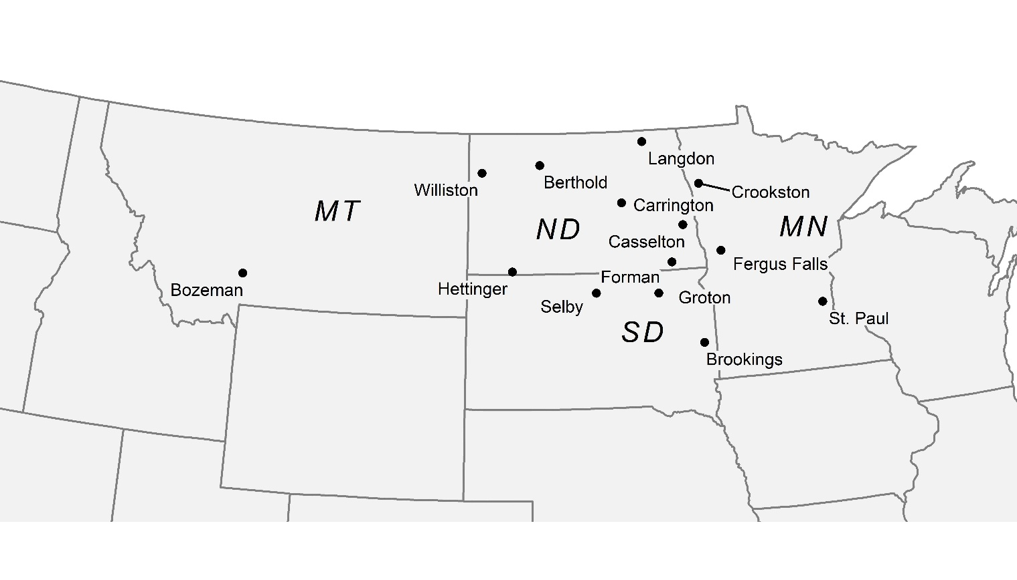

Figure 2. Average trait values by genotypes at all locations for the 2025 HRSWURN

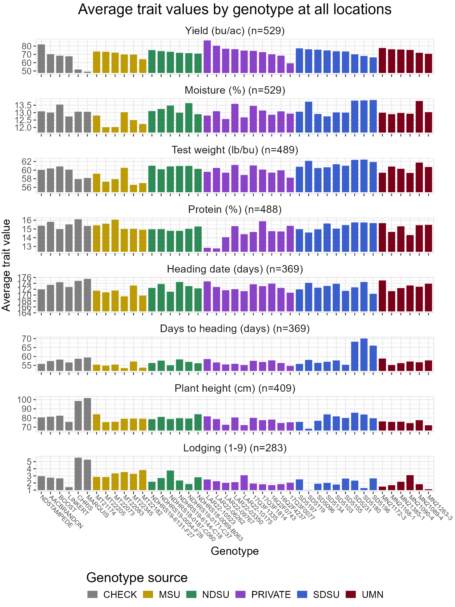
Figure made by Charlotte Brault

